Pass by Value and Pass by Reference: Student Lab #2

This lab presents two versions of a function that cubes an integer—cubeByValue and cubeByReference

Pass by Value

First program passes the variable number by value to function cubeByValue. The cubeByValue function cubes its argument and passes the new value back to main using a return statement. The new value is assigned to number in main.

*Expected Output:*

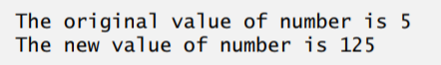

TYPE the Following Code, Then Compile and Run it:

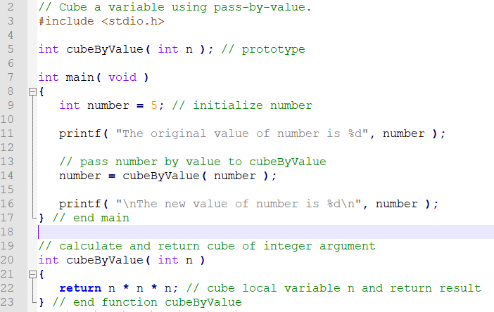

*Expected Output:*

PASS BY RERENCE:

Figure 7.7 passes the variable number by reference (line 15)—the address of number is passed—to function cubeByReference. Function cubeByReference takes as a parameter a pointer to an int called nPtr (line 21). The function dereferences the pointer and cubes the value to which nPtr points (line 23), then assigns the result to \*nPtr (which is really number in main), thus changing the value of number in main. Figures 7.8 and 7.9 analyze graphically and step-by-step the programs in Figs. 7.6 and 7.7, respectively.

*Expected Output:*

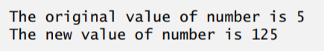

TYPE the Following Code, Then Compile and Run it:

